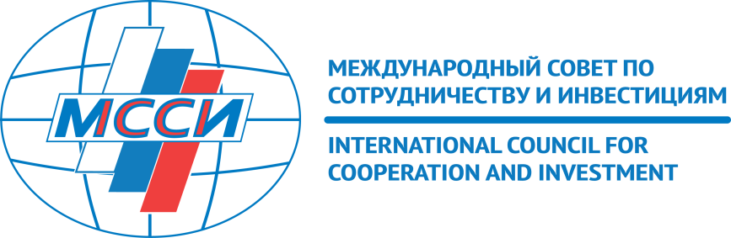

International Council for Cooperation and Investment (ICCI) meeting
11 December 2018 at 16:00
Venue: RSPP (17 Kotel’nicheskaya naberezhnaya Moscow), “Kotelnichesky” room
Welcome remarks
Dr. Alexander Shokhin, President, Russian Union of Industrialists and Entrepreneurs (RSPP); Chair, International Council for Cooperation and Investment (ICCI)
- Improving the investment climate in Russia
- The draft law on protection and promotion of the investments in Russia
Mr. Frank Schauff, Director General, Association of European Businesses (AEB)
Discussion
F. Baldisserotto, Vice-president for localization, Confindustria Russia
- Proposals of China Council for the Promotion of International Trade (CCPIT) on promotion of the PRC’s investment in the Russian Federation
Mr. Xu Jinli, Chief Representative of China Council for Promotion of International Trade (CCPIT) in Russia
Discussion
- Developing the tax legislation
- AEB proposals on Value Added Tax (VAT) and Profit Tax (PT) application
Dr. Alina Lavrentieva, Association of European Businesses (AEB), Taxation Committee Chair
- Impact of the VAT increase on implementation of the suppliers’ obligations under the state contracts
Mrs. Natalia Schneider, Vice-president, American Chamber of Commerce in Russia.
Discussion
- Enhancing intellectual property protection
- Patent register as an instrument to harmonize Federal law № 61-FZ with the Eurasian Economic Union rules on provision of the intellectual property rights data by applicants
- Mr. Vadim Kukava, Executive Director, Association of Pharmaceutical Companies “Innovative Pharma” (InPharma)
Discussion
Concluding remarks: ICCI priorities for 2019
Dr. Alexander Shokhin, President, Russian Union of Industrialists and Entrepreneurs (RSPP); Chair, International Council for Cooperation and Investment (ICCI).

